**Prometheus installation**

What is prometheus ?

Prometheus is a software application user for event monitoring and alerting,

time serices database

Why use?

Records any purly numeric time serices

Machine-centric and highly dynamic service oriented architectures

First create one ec2 instance to add port numbers

9090 port no prometheus

3000 port no grafana

9100 port no node-exporter

Prometheus

1.ubuntu@ip-172-31-25-79:~$ sudo useradd prometheus

2.ubuntu@ip-172-31-25-79:~$ sudo mkdir /etc/prometheus

3.ubuntu@ip-172-31-25-79:~$ sudo mkdir /var/lib/prometheus

4.ubuntu@ip-172-31-25-79:~$ wget https://github.com/prometheus/prometheus/releases/download/v2.38.0/prometheus-2.38.0.linux-amd64.tar.gz

5.ubuntu@ip-172-31-25-79:~$ sudo chown prometheus:prometheus /var/lib/prometheus

6.ubuntu@ip-172-31-25-79:~$ tar -xvf prometheus-2.38.0.linux-amd64.tar.gz

7.ubuntu@ip-172-31-25-79:~$ mv prometheus-2.38.0.linux-amd64 prometheus-files

8.ubuntu@ip-172-31-25-79:~$ sudo cp prometheus-files/prometheus /usr/local/bin/

9.ubuntu@ip-172-31-25-79:~$ sudo cp prometheus-files/promtool /usr/local/bin/

10.ubuntu@ip-172-31-25-79:~$ sudo chown prometheus:prometheus /usr/local/bin/prometheus

11.ubuntu@ip-172-31-25-79:~$ sudo chown prometheus:prometheus /usr/local/bin/promtool

1. ubuntu@ip-172-31-25-79:~$ sudo vi /etc/prometheus/prometheus.yml (to add the ips)

global:

scrape_interval: 15s

external_labels:

monitor: 'prometheus'

scrape_configs:

- job_name: 'promethues '

static_configs:

- targets: ['public ip:9090']

ubuntu@ip-172-31-36-207:~$ sudo systemctl restart prometheus

13.ubuntu@ip-172-31-25-79:~$ sudo chown prometheus:prometheus /etc/prometheus/prometheus.yml

14.ubuntu@ip-172-31-25-79:~$ sudo vi /etc/systemd/system/prometheus.service

[Unit]

Description=Prometheus

Wants=network-online.target

After=network-online.target

[Service]

User=prometheus

Group=prometheus

Type=simple

ExecStart=/usr/local/bin/prometheus \

--config.file /etc/prometheus/prometheus.yml \

--storage.tsdb.path /var/lib/prometheus/ \

--web.console.templates=/etc/prometheus/consoles \

--web.console.libraries=/etc/prometheus/console_libraries

[Install]

WantedBy=multi-user.target

(15.ubuntu@ip-172-31-25-79:~$ sudo chown -R prometheus:prometheus /etc/prometheus/consoles)

16.ubuntu@ip-172-31-25-79:~$ sudo systemctl daemon-reload

17.ubuntu@ip-172-31-25-79:~$ sudo systemctl start prometheus

18.ubuntu@ip-172-31-25-79:~$ sudo systemctl status prometheus

Remember that ec2-13-58-127-241.us-east-2.compute.amazonaws.com is the DNS value of node-exporter installed Ec2 instance.

** Restart Prometheus service.

sudo systemctl restart prometheus

Try It Out

Now in your browser navigate to http://ec2-3-17-28.53.us-east-2.compute.amazonaws.com:9090/targets . Remember to change the url accordingly to your Prometheus AWS EC2 instance details

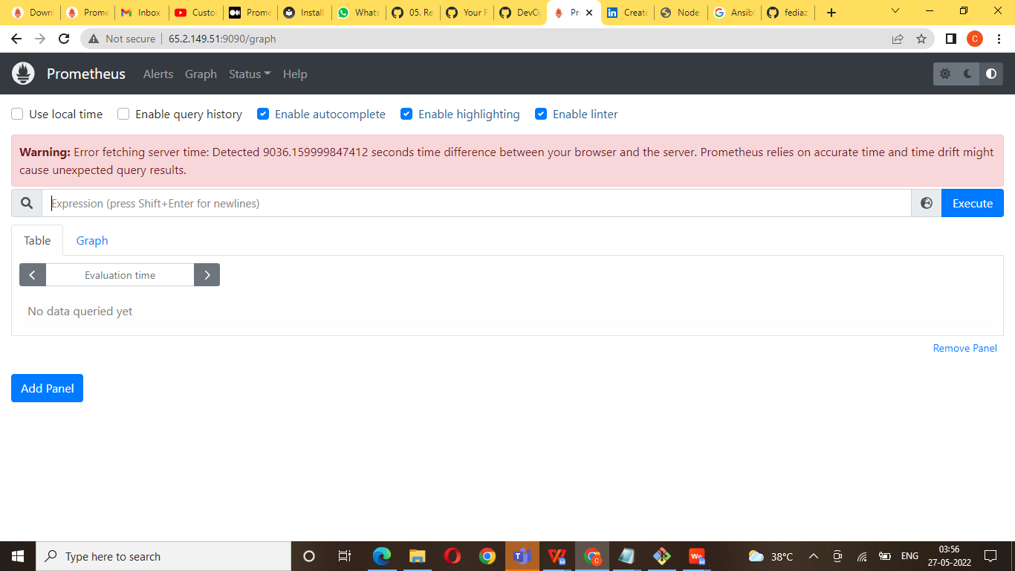

Prometheus installation link below

https://devopscube.com/install-configure-prometheus-linux/

Node exported

What is a node exporter?

Node Exporter is a Prometheus exporter for server level and OS level metrics with configurable metric collectors. It helps us in measuring various server resources such as RAM, disk space, and CPU utilization

Create instance ec2 Ubuntu port no : 9100

Connect terimaninal

1. ubuntu@ip-172-31-36-207:~$ wget https://github.com/prometheus/node_exporter/releases/download/v1.4.0-rc.0/node_exporter-1.4.0-rc.0.linux-amd64.tar.gz

2. ubuntu@ip-172-31-36-207:~$ tar -xvf node_exporter-1.4.0-rc.0.linux-amd64.tar.gz

3.ubuntu@ip-172-31-36-207:~$ cd node_exporter-1.4.0-rc.0.linux-amd64

4.ubuntu@ip-172-31-36-207:~/node_exporter-1.4.0-rc.0.linux-amd64$ sudo cp node_exporter /usr/local/bin/

5 ubuntu@ip-172-31-36-207:~/node_exporter-1.4.0-rc.0.linux-amd64$ cd ..

6. ubuntu@ip-172-31-36-207:~$ sudo useradd --no-create-home --shell /bin/false node_exporter

7 ubuntu@ip-172-31-36-207:~$ sudo chown node_exporter:node_exporter /usr/local/bin/node_exporter

8 ubuntu@ip-172-31-36-207:~$ sudo vi /etc/systemd/system/node_exporter.service

[Unit]

Description=Node Exporter

Wants=network-online.target

After=network-online.target

[Service]

User=node_exporter

Group=node_exporter

Type=simple

ExecStart=/usr/local/bin/node_exporter

[Install]

WantedBy=multi-user.targ

9 ubuntu@ip-172-31-36-207:~$ sudo systemctl daemon-reload

10 ubuntu@ip-172-31-36-207:~$ sudo systemctl start node_exporter

Go to prometheus below path and edit yaml file and add node_expoter

11.sudo vi /etc/prometheus/prometheus.yml (copy and paste below code)

global:

scrape_interval: 15s

external_labels:

monitor: 'prometheus'

scrape_configs:

- job_name: 'promethues '

static_configs:

- targets: ['public ip:9090']

- job_name: 'node_exporter '

static_configs:

- targets: ['public ip:9100']

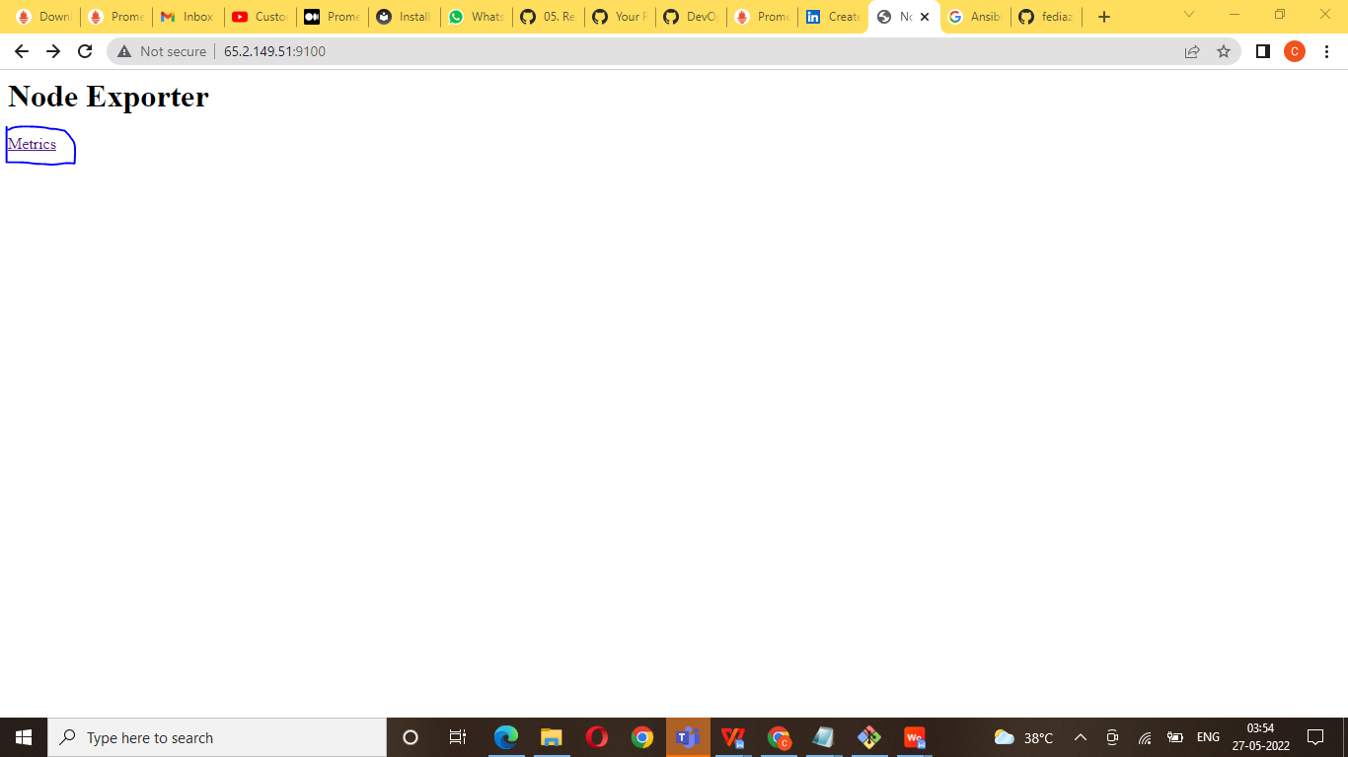

Grafana

Grafana  is a [multi-platform](https://en.wikipedia.org/wiki/Multi-platform" \o "Multi-platform) [open source](https://en.wikipedia.org/wiki/Open_source" \o "Open source) analytics and [interactive visualization](https://en.wikipedia.org/wiki/Interactive_visualization" \o "Interactive visualization) web application. It provides charts, graphs, and alerts for the web when connected to supported data sources.

Grafana install:

1.ubuntu@ip-172-31-36-207:~$ sudo apt-get install -y adduser libfontconfig1

2.ubuntu@ip-172-31-36-207:~$ wget <https://dl.grafana.com/enterprise/release/grafana-enterprise_9.1.1_amd64.deb>

1. ubuntu@ip-172-31-36-207:~$ sudo dpkg -i grafana-enterprise_9.1.1_amd64.deb
2. ubuntu@ip-172-31-36-207:~$ sudo systemctl daemon-reload
3. ubuntu@ip-172-31-36-207:~$ sudo systemctl start grafana-server
4. ubuntu@ip-172-31-36-207:~$ sudo systemctl status grafana-server

7.ubuntu@ip-172-31-36-207:~$ sudo systemctl enable grafana-server.service

Go to prometheus below path and edit yaml file and add node_expoter

9.sudo vi /etc/prometheus/prometheus.yml (copy and paste below code)

global:

scrape_interval: 15s

external_labels:

monitor: 'prometheus'

scrape_configs:

- job_name: 'promethues '

static_configs:

- targets: ['public ip:9090']

- job_name: 'node_exporter '

static_configs:

- targets: ['pubilc:9100']

- job_name: 'grafana '

static_configs:

- targets: ['pubilc ip :3000']

Now open it on the browser using below url:

Make sure that port 3000 is open for this instance.

http:// yourip:3000

Login username and password :admin and password admin

